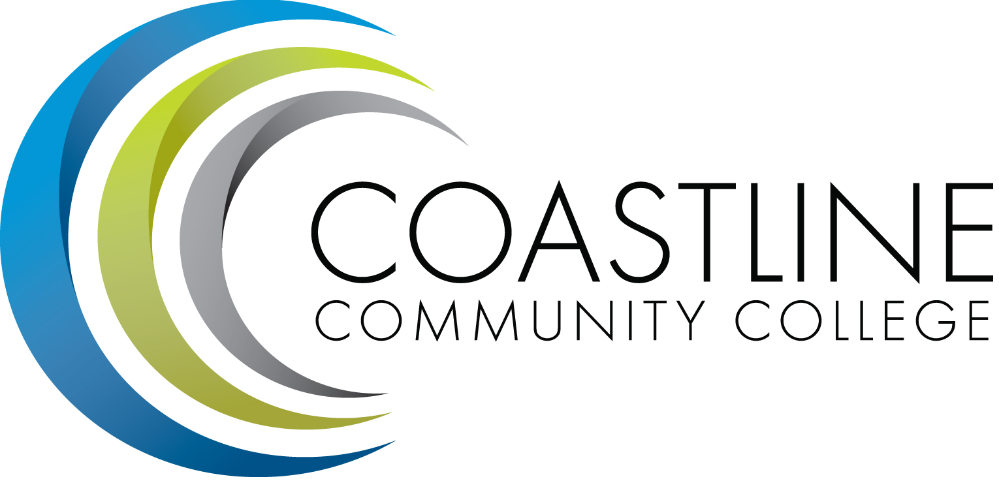
Coastline Management Meeting (CMT) Minutes
SPECIAL MEETING
July 19, 2017
9:00 – 11:00 a.m.
4th Floor Conference Room

Name | Present | Name | Present | Name | Present
Adrian, Lori | X | Emerson, Dana |  | Miyashiro, Ross | X
Akins, Renate | X | Garvey, Judy | X | Nash, Bob | X
Barnes, Stephen |  | Groot, Joycelyn | X | Neal, Tom | X
Blair, Shelly | X | Gutierrez, Rene |  | Nguyen, Christine | X
Brais, Nathan |  | Harrison, Nate | X | Rodriguez, Vince | X
Cant, Dave |  | Jones, Nancy | X | Rothgeb, Helen | X
Capoccia-White, Rozanne | X | Keeler, Bruce | X | Sanchez, Jorge | X
Colver, Mike | X | Khosravani, Mariam | X | Scott, Michael | X
Dahnke, Lynn | X | Le, Mai |  | Thompson, Dave | X
De La Rosa, Jennifer | X | McDonald, Jennifer |  | Woodyard, Steve | X
Donahue, Kevin |  | Mendez, Julie |  | Zentner, Aeron
Recorder: Martha Tran-Nguyen
Transcriber: Kathy Surgenor

- CALL TO ORDER
  - Roll Call
  - Welcome: Dr. Lori Adrian welcomed the committee and introduced Shelly Blair, Dean of Innovative Learning. She commended Shelly on the work she completed for the Summer Institute.
  - Adoption of **Agenda

- Closing the Loop: Management Retreat 2016 (Retreat Planning Committee) – Dr. Adrian discussed last year’s Retreat Team that was comprised of Joycelyn, Dana, Renate, Bruce, Rozanne, and Aeron. Joycelyn provided a brief synopsis about the background of the Coastline Management Team Mission, Vision, Values, etc. Copies of the CMT Outline was distributed and Joycelyn described changes recommended and made to the Vision, Mission, Culture and Visions for CMT. Dr. Adrian mentioned the leadership aspect and advised how to incorporate it into the Vision/Mission statements. She shared her thoughts about CMT’s Vision and suggested how wording of the Mission Statement could be structured and then asked for input from the Committee. A lengthy discussion ensued amongst Dr. Adrian and the committee about utilization of the word “innovation” and what it means for Coastline’s Vision, Culture, and core message. The Committee agreed with most of Dr. Adrian’s revisions to the CMT Mission, Vision, Values and Culture statements. They recommended various additional changes to the wording and versions of statements within the CMT Outline. Following the discussion, Dr. Adrian appointed Shelly Blair to form a small work group to review and revise the Outline and statements for Mission, Vision, Values, and Culture for CMT.

- Management Retreat Agenda – July 24, 25……………………………………………………. (Lori/All)
Dr. Adrian and the committee reviewed the Management Retreat Agenda to be held at Hotel Laguna. Mariam Khosravani advised members about the location and requirements for valet parking. Dr. Adrian mentioned that parking fees will be reimbursed to members. A continental breakfast and lunch will be served at the Retreat and in the evening hors d'oeuvres will be served during a social hour followed by dinner. Dr. Adrian reviewed an outline of the Retreat Agenda/Program schedule, including books, topics, presentations, and speakers which will be provided throughout the two-day retreat. She asked for additional ideas and input from the committee. Day Two will be a Planning Session beginning at 8:30 a.m. Joycelyn described the presentation she will conduct along with Dr. Vince Rodriguez about the “student experience” at the Retreat. Vince discussed the student application process and asked members to apply and go through the application/enrollment process in order to experience what students go through when applying to the college. Dr. Adrian asked members to identify key goals and objectives for the upcoming year during the planning session. Wings will identify their individual Wing priorities. Social gatherings will take place so members can mingle and discuss ideas with others throughout the retreat.

- Personal Vision for Coastline……………………………………………………………………. (Lori)
Dr. Adrian discussed the personal vision statement for the College and shared her thoughts, ideas, and inspiration for narrative structure of the vision statement. She expressed that the statement should be focused towards serving students, providing leadership, encouraging student success, and setting standards for excellence. Members shared ideas about goals and motivation factors towards efficiency and creativity.
- Working towards a shared vision for Coastline…………………………………………. (Lori/All)
Dr. Adrian advised that PIEAC will address the shared vision for Coastline. She discussed the current vision and requested input from the Team. Members expressed their points of view and ideas with regard to improving and revising the shared vision statement. Dr. Adrian referred to the 30-Year Anniversary document about Coastline and discussed the important message derived from that document. She described access to Coastline, vision of the college, diversity, strategies for student success, and structured pathways. Members shared various ideas for the vision message of Coastline. Key factors to be considered are: creativity, identifying values, the mission, and the vision statements.
- Core Messages on Coastline.…………………………………………………………………….(Lori)

- SUMMARY OF KEY ITEMS DISCUSSED/ACTIONS TAKEN
7.1 Review of 2016-17 Retreat
7.2 Review of CMT Outline for Mission, Vision, Values, and Culture statements
7.3 Review of Management Retreat Program/Agenda
7.4 Review of Personal Vision for Coastline
7.5 Review of Shared Vision for Coastline

Documents Distributed:
- CMT Outline for Mission, Vision, Values, and Culture statements
- Management Retreat Program/Agenda
- List of Factors/Attributes
- Values Exercise Report
- Preliminary Perspective for Marketing Report
- Marketing Plan for Recruiting Online Students Report

Next Meeting: August 1, 2017, 9:00 a.m., 4th Floor Conference Room
*Attachment emailed
**Attachment provided at meeting

